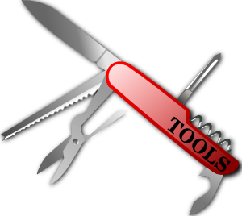***Shiny Things!!!! Assignment***

***Module:*** WLD1030

***Materials:*** Students will need access to computer and printer, internet and various documents. Items for creating personal survival and first aid kits will also be needed. Discussions regarding acquiring equipment will also prepare students for collecting the gear they needed for an outdoor excursion.

**Safety:**  There will be discussion about knives and axes which will allow students to bring their own axes and knives to school ***but only with prior permission and following specific guidelines and rules***. Horseplay with knives, axes, or any other potentially dangerous equipment will result in loss of privileges.

***Assignment:***

“Personal Equipment List” Assignment - Personalize an equipment list for a three day backpacking adventure. Rank the top ten pieces of equipment in order of importance. Use the sample equipment lists located on the class website as a guide and modify, or create your own, which reflects your personal needs. It must be presented in a format which allows for checking “have it, need it, packed it”.(WLD1030)***

“Personal Survival Kit” Assignment - Research and build a personal survival kit. Research and design a personal survival kit and one for a group of 4. Build the personal kit - it must be carried with you on the survival camp and will be used as part of several activities. (WLD1030)***

“Personal First Aid Kit” Assignment – Research, design and build a personal first aid kit. Research and design a first aid kit for a group of 4. Create a single sheet of important, basic first aid information and practices which can be laminated and included in your personal first aid kit. Build the personal kit - it must be self-contained in a durable, water-resistant container and carried in your day pack while on the survival camp. (WLD1030)***

“Make Fire, Big Smoke” Assignment - Demonstrate several ways to safely start a fire. Practice at least two different methods of starting fires and include any supplies for those two methods in your personal kit for the survival camp. (WLD1030)***

“Stinky or Not Stinky” Assignment - Research personal hygiene practices for outdoor excursions. Make a “do’s and don’ts” list. Ensure your personal equipment list reflects your research. (WLD1030)***

***References:***

Worksheets Internet resources Class website

SRD website Print resources